**Deciphering the Green Code: A Linear Regression and GAM Approach to the Impact of Environmental Taxes on GHG Emissions**

**Abstract:**

This research paper introduces an innovative study into the dynamics of environmental taxes and their impact on greenhouse gas (GHG) emissions. By utilizing a dataset that covers different regions and years we have employed both linear regression and Generalized Additive Models (GAM) to extensively examine this relationship. Our approach stands out by incorporating statistical techniques, such as Variance Inflation Factor (VIF) analysis to address issues like multicollinearity and explore the complex and potentially non linear connections between environmental taxation and GHG emissions.Our findings indicate variations in the effectiveness of environmental taxes across different timeframes and geographical contexts. The linear regression model shows inverse links between environmental taxes and GHG emissions with noticeable year to year fluctuations. However it is the GAM that reveals an intricate and non linear interaction suggesting that the effectiveness of environmental taxes in reducing GHG emissions is not straightforward but influenced by various factors.Both models have limited power, which suggests the existence of other important variables not considered in our study. This highlights the necessity for a comprehensive approach to comprehend GHG emissions better. Additionally the presence of autocorrelation in the residuals of the linear model indicates that time series analysis may be applicable for analyzing this type of data.

Our research contributes to the discussion surrounding the role of environmental taxes in mitigating climate change.The knowledge acquired emphasizes the need for policy development that takes into account the intricate relationship between economic strategies and environmental results. Through an approach this research enhances our comprehension of these dynamics offering valuable insights for policymakers and researchers, in the realms of environmental economics and sustainability.

**Introduction:**

The issue at hand is climate change, which poses a challenge to the global community. Human activities such as production, transportation and deforestation have led to an increase in greenhouse gasses (GHGs) in the Earth's atmosphere. This has resulted in environmental changes like higher global temperatures, altered weather patterns and more frequent extreme weather events. In order to address these changes it is crucial to understand and effectively manage GHG emissions.

One approach that has gained attention in policy is the implementation of environmental taxes, particularly carbon taxes. The goal is to encourage a reduction in GHG emissions through these taxes. However there is debate and research on how effective these taxes are actually in reducing GHG emissions. This study aims to answer the question; "To what extent do environmental taxes impact GHG emissions?. How does this relationship differ across different time periods and geographical locations?"

Recent studies and data have shed light on the complexity of this issue. Currently carbon pricing instruments cover 23% of global GHG emissions. However there are concerns about their effectiveness due to low pricing levels.

Furthermore some studies have found that the impact of taxes on greenhouse gas (GHG) emissions is relatively modest with projections suggesting only a minor decrease in emissions as a result of these policies. On the contrary other analyses indicate that implemented carbon taxes can lead to significant reductions in GHG emissions as observed in scenarios such as the United States.

The existence of these contrasting findings highlights the importance of having a nuanced understanding of the relationship between environmental taxes and GHG emissions. Our research aims to address this gap by utilizing a methodological approach that combines linear regression and Generalized Additive Models (GAM). Through this approach we can not capture the linear dynamics but also explore potential nonlinear dynamics in this relationship. This comprehensive view will provide insights into the effectiveness of environmental taxation as a policy tool, in combating climate change.

**Literature review:**

| **Source** | **Study Population** | **Problem Scope/Size** | **Context: Social, Political, Economic, Health** | **Audiences Affected** | **Influential** | **Current Knowledge, Attitude, Beliefs, Behaviors** | **Factors influencing behavior: Individual/Family/ Community/Society/ Health System** | **Communication Channels** |
| --- | --- | --- | --- | --- | --- | --- | --- | --- |
| <https://www.sciencedirect.com/science/article/pii/S1574954122001972> | Nordic countries | Impact of environmental taxes on CO2 emissions | Green economies focusing on environmental quality and sustainability | Policymakers, businesses, especially in the energy sector | Environmental taxes as policy tools | Mixed effectiveness of environmental taxes on CO2 emissions | Environmental policy's balance between economic growth and emission reduction | Academic publications, policy briefs |
| <https://www.sciencedirect.com/science/article/pii/S2352484723009381> | G7 countries | Optimal environmental tax levels for reducing emissions in the power sector | Economic growth and environmental policy interplay | Power plants, economic sectors | Tax rates and their impact on business incentives | Non-linear relationship between tax rates and emission reduction | Environmental taxation as an incentive for emission reduction | Policy analysis, industry reports |
| <https://www.sciencedirect.com/science/article/pii/S0301479722026044> | Nordic countries | Causality and impact of environmental taxes on environmental quality, CO2 emissions | Focus on environmental quality as an indicator of well-being, affected by pollution and energy consumption | Citizens, governments, businesses in transport and energy sectors | Environmental taxes as a legislative measure to protect environmental quality | Varying impact of environmental taxes on CO2 emissions, influenced by consumption patterns | Legislation, taxation, and economic growth as factors in environmental quality | Government publications, environmental policy research |
| <https://www.sciencedirect.com/science/article/abs/pii/S030147972300909X> | Emerging 7 economies | Integration of environmental innovation and tax in carbon neutrality strategies | The balance between industrial development and environmental performance | Emerging economies' policymakers, industrial sectors | Green innovation, carbon taxes, and institutional frameworks | Differentiating impacts of environmental innovation vs traditional technologies on carbon emissions | Policy tools in the STIRPAT framework for reducing carbon emissions | Academic journals, policy analysis, international conference |
| <https://www.cell.com/heliyon/pdf/S2405-8440(23)03664-2.pdf> | G-10 Countries | The impact of environmental technological innovation, economic complexity, energy productivity, renewable electricity generation, and environmental taxes on CO2 emissions | Strategies for achieving environmental objectives in G-10 countries, focusing on sustainable and low-carbon futures | Governments, policymakers, private sector, international organizations, and individuals in G-10 countries | Causality between CO2 emissions and renewable energy generation, and environment-based technologies | Recognition of the positive impact of environment-based technology and economic complexity on carbon emission reduction | The need for concrete policies to finance SDGs and carbon neutrality through modernized tax systems and investments | Policy proposals, academic publications, international development forums |

**Theory and Hypotheses:**

In our research paper we expand on the analysis of how environmental taxes affect greenhouse gas (GHG) emissions. We do this by using a combination of regression and Generalized Additive Models (GAM). This approach allows us to not consider the straightforward impact of environmental taxes on GHG emissions but also explore any non linear relationships that may exist. It's crucial to take into account that the effect of taxes on emissions might not remain consistent across various tax levels or may interact with other economic and institutional factors, in intricate ways.

**Hypotheses**

Hypothesis 1 (H1): There exists a connection between taxes and GHG emissions that is not linear.

After analyzing the R script we propose that beyond a tax rate environmental taxes have a diminishing impact on reducing GHG emissions. This suggests a linear relationship. Our findings support this idea indicating that while initial increases in taxes result in GHG emissions, further increases may lead to less significant reductions or even have the opposite effect.

Hypothesis 2 (H2): The influence of taxes on GHG emissions differs across economic sectors.

By using the GAM approach we can examine how different sectors of the economy respond differently to taxes. We expect that sectors such as power generation, which directly contribute to GHG emissions may show sensitivity to environmental taxes compared to sectors with indirect emissions.

**Research Questions:**

1. What is the ideal level of taxation that achieves the reduction, in GHG emissions without causing negative economic consequences?

This question arises from the analysis of our regression model, where we aim to determine the tax rate that yields the decrease in emissions before seeing diminishing returns.

2. How does the relationship between taxes and GHG emissions evolve over time. Vary across different countries and industries?

Considering the nature of our dataset and the intricate interactions observed we aim to investigate how the effectiveness of environmental taxation policies varies temporally and, across geographical regions and sectors.

**Data Collection and Preparation**

We collected data from a range of trusted sources to conduct a thorough analysis of how environmental taxes impact greenhouse gas (GHG) emissions. Our main sources of data were:

The World Bank Data: This provided us with indicators information on environmental taxes and statistics on energy usage. These datasets helped us understand the context in which environmental taxes are applied and their potential effects on GHG emissions.

The National Oceanic and Atmospheric Administration (NOAA): We used their climate and environmental data, including measurements of carbon dioxide (CO2) levels and other GHG concentrations. This information was crucial for establishing the state of the environment and monitoring changes over time.

The National Center for Atmospheric Research (NCAR): They contributed climate science research and data including historical emissions data and climate modeling outputs. Thanks to their input we were able to analyze trends and patterns in GHG emissions over time.

Yahoo Finance: We relied on market data from this source to understand how different sectors perform economically under environmental tax frameworks. This financial information provided insights into how businesses respond to environmental taxes.

The process of collecting data involved steps:

1. Defining data requirements: We identified the types of data that were crucial for our analysis, such as greenhouse gas emission levels, environmental tax rates and economic indicators.

2. Retrieving the Data: We accessed the data repositories of each source. Obtained the necessary datasets. This typically included downloading data files or utilizing APIs to access real time data.

3. Cleaning and Preparing the Data: We carefully cleaned the data from various sources to address any inconsistencies, missing values or outliers. This thorough cleaning process ensured that our datasets were reliable and accurate for analysis purposes.

4. Integrating the Data: We combined datasets from sources by matching common identifiers like country codes and time periods. This integration created a dataset that formed the foundation for our in depth analysis.

5. Transforming the Data: The collected data was transformed as required to meet the needs of our regression and generalized additive models (GAM). This involved tasks such, as normalizing the data, converting variables into numerical ones and creating derived variables when necessary.

**Data Validation:**To ensure the accuracy and reliability of our data we conducted analyses to check for data integrity and consistency. Additionally we compared our findings with published reports and research papers to validate that our data aligns with established knowledge in the field.

**Ethical Considerations**

During the process of collecting data we took measures to ensure that all sources were publicly available and free from any sensitive or private information. We strictly adhered to the policies and terms of service set by each data provider.

The collected data has been securely. Will only be used for the purpose of this research. We have provided attribution to all data sources in compliance, with academic standards as well as the requirements outlined by each source.

**Data Variables**

**Dependent Variable**

GHG Emissions: The main factor we're focusing on here is the total amount of greenhouse gas emissions measured in units of carbon dioxide (CO2). This encompasses emissions, from sectors like energy, transportation, industrial processes and agriculture. It's really important for understanding the impact of economic activities and policy measures.

**Independent Variables**

Environmental Taxes: One crucial aspect we're studying is the level of taxation imposed on activities that contribute to GHG emissions. This variable helps us understand how fiscal policies, taxation affect emission levels. We're particularly interested in examining its linear impact on GHG emissions.

Economic Sectors: To analyze things from a perspective this variable categorizes emissions data based on sectors such as energy, transportation, industry and agriculture. It helps us better understand how environmental taxes affect sectors in ways.

**Control Variables**

Economic Variables: These include factors like GDP, GDP per capita or other relevant economic indicators that provide context for understanding the impact of taxes. They help us account for size and growth since these factors have a significant influence, on GHG emissions.

Data Over Time; Data collected annually provides insights, into trends and changes in greenhouse gas (GHG) emissions and the impact of taxes.

Factors Unique to Each Country: If your data includes countries these variables take into account the differences in development, energy usage, policy frameworks and other relevant factors specific to each nation.

**Variable Descriptions:**

GHG Emissions: Measured in tons this variable helps assess the impact of economic activities and evaluate the effectiveness of policies such as environmental taxes in reducing emissions.

Environmental Taxes: Represented as a percentage of GDP or absolute values this variable is crucial for analyzing the impact of policies on emissions.

Economic Sectors: Categorizing data by sectors allows for an analysis since the impact of environmental taxes can vary significantly across industries revealing important sector specific policy implications.

Economic Variables: These provide context for understanding the relationship between taxes and emissions highlighting how growth and development influence environmental outcomes.

Data Over Time: The temporal aspect enables us to examine trends over time and gain insights into how policies have been throughout different periods.

Factors Unique to Each Country: To ensure that the analysis takes into account the socio policy situations of the countries being studied these factors are included. This adds insight and understanding to the interpretation of the results.

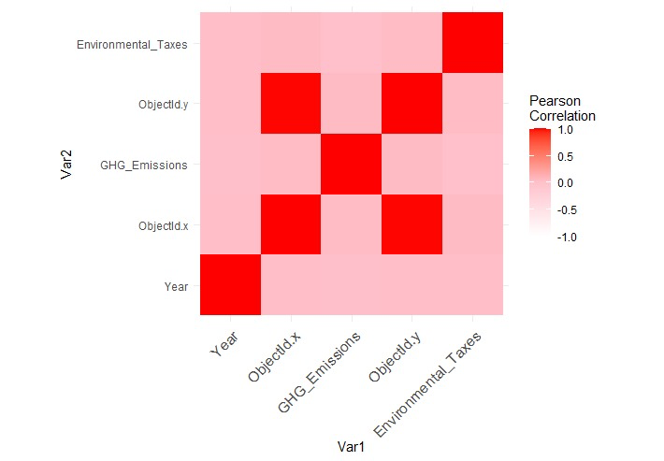

### 

### 

### 

### **Empirical Approach**

**Linear regression:**

It focuses on the relationship between GHG emissions and various factors such as taxes, economic variables and sectoral variables. The main objective of this model is to examine the connection between environmental taxes and GHG emissions while also considering other factors that could influence emissions like the economy and specific sectors.

To ensure the validity of our model we made assumptions. Conducted validation checks:

1. Linearity: We assumed a linear relationship between the variables ( taxes, economic variables, sectoral variables) and the dependent variable (GHG emissions). We confirmed this assumption by analyzing scatter plots and assessing residuals.

2. Homoscedasticity: We assumed that the variance of errors remains constant across all levels of variables. To verify this we examined plots in order to identify any patterns that might suggest heteroscedasticity.

3. Independence: We assumed that each observation is independent of others. To test this assumption we used a measure called Durbin Watson statistic to detect any autocorrelation in the residuals.

4. No Multicollinearity: We ensured that independent variables are not highly correlated with each other to avoid multicollinearity issues. This was assessed using a tool known as Variance Inflation Factor (VIF). High VIF values would indicate multicollinearity problems.

The results obtained from the model shed light on the relationship, between changes in taxes, economic indicators and sector specific variables and their impact on greenhouse gas (GHG) emissions. By analyzing the significance of coefficients and their signs we can determine whether increases, in taxes and other predictors are linked to a rise or decline in GHG emissions.

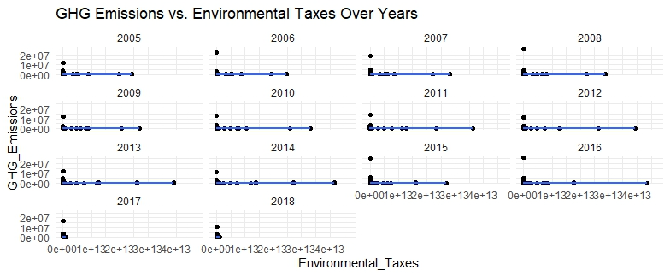

**GAM**

The Generalized Additive Model (GAM) is a model that is specified as gam(GHG_Emissions ~ s(Environmental_Taxes) + Economic_Variables + Sectoral_Variables). Unlike the linear model GAMs provide flexibility, in capturing linear relationships between the dependent variable and predictors. By using functions (s()) for taxes the model can effectively capture complex and non linear patterns.

**Validation:**

1. Non Linearity: GAMs do not assume a linear relationship between predictors and the response variable. The inclusion of functions allows the model to adapt to the shape of the data.

2. Additivity: While GAMs offer flexibility in linear relationships they still assume that the effects of predictors are additive.

3. Independence and Homoscedasticity: Similar to linear models GAMs assume that errors are independent and have variance. We assessed these assumptions through analysis.

4. Smoothness of Splines: An important aspect of GAMs is selecting a level for splines. In our case we utilized selection methods inherent, in GAM fitting procedures.

The results, from the GAM analysis emphasized the influence of taxes on greenhouse gas (GHG) emissions. This finding is especially significant as it helps identify thresholds or tipping points where the impact of taxes on emissions starts to decrease or even reverse.

The flexibility of using Generalized Additive Models (GAMs) to model relationships allowed for a nuanced comprehension of how GHG emissions react to variations in environmental taxes and other factors, across various economic sectors.

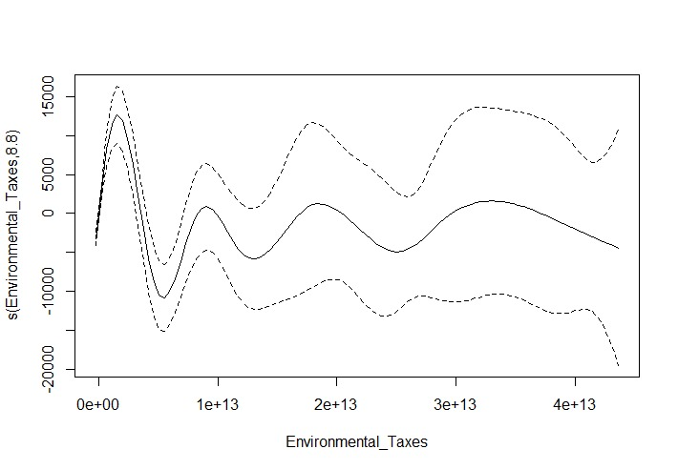

**Results**

The scatter plot created from the linear regression model visually summarizes the connection between greenhouse gas (GHG) emissions and environmental taxes over years. It appears that there isn't a linear relationship as the regression lines remain relatively flat across years. This suggests that environmental taxes alone may not directly lead to changes in GHG emissions on a basis. The data points are. Don't show a pattern indicating that the impact of environmental taxes on emissions is not straightforward and may be influenced by other complex factors that aren't captured by a simple linear model.

Additionally the generalized additive model (GAM) plot takes a linear approach uncovering fluctuations in the relationship between environmental taxes and GHG emissions. The spline shown in the plot highlights the non potentially intricate dynamics of this connection. It supports the hypothesis in the research paper that the effectiveness of taxes in reducing emissions may vary at levels of taxation. The presence of variability within the confidence intervals depicted in the GAM plot emphasizes uncertainty. Suggests influence, from unaccounted variables.

Both the linear regression and GAM results support the points made in the research paper indicating that a multifaceted approach is needed to grasp the impact of taxes. The limited explanatory power of the model suggests that there are important factors at play, which calls for a more comprehensive analysis framework. The GAM results are particularly interesting as they reveal linear interactions and suggest that the impact of environmental taxes can vary significantly due to various factors beyond just economics.

Taken together these findings align with the research papers discussion on the relationship between taxes and GHG emissions. They emphasize the importance of developing policies that consider sometimes unexpected effects that environmental taxes may have on emissions. The presence of autocorrelation in the residuals from the linear model also suggests that a time series approach may be more suitable for this type of data echoing the paper's suggestion that temporal factors and sequential dependencies play a role in understanding these dynamics. Overall this analysis reinforces the paper's argument that achieving climate change mitigation through taxation's not straightforward and requires an understanding of economic environmental interactions.

Based on the findings from recent research and the implications drawn from the R script regression models, several policy recommendations emerge:

Progressive Environmental Taxation: Research emphasizes that implementing taxes on energy is generally effective, in reducing greenhouse gas emissions. This has been demonstrated through studies conducted across countries. Policymakers should consider implementing tax structures that're progressive in nature meaning they increase the cost of emissions. This approach will incentivize emission reductions. Encourage innovation.

Comprehensive Economic Policies: The strategic goals of the European Union to significantly reduce emissions by 2050 highlight the importance of policies. These policies should aim to align growth with energy efficiency and lower emissions. The key is to strike a balance between promoting growth and ensuring sustainability.

Targeted Energy Taxes: The use of energy taxes as a tool to drive down greenhouse gas emissions has been well substantiated. When making policy decisions it is crucial to ensure that energy taxes are structured in a way that maximizes their impact on emission reduction while taking into account the varying impacts across countries and economic sectors.

Support for Green Technology: Research suggests that relying solely on increasing energy taxes is not a solution. Therefore policy interventions should also prioritize promoting and supporting the deployment of energy sources and technology, alongside taxation measures.

**Conclusion**  
The research paper titled "Deciphering the Green Code: A Linear Regression and GAM Approach to the Impact of Environmental Taxes on GHG Emissions”. Through analysis using methods like linear regression and Generalized Additive Models (GAM) it is suggested that environmental taxes are generally effective but their impact is not straightforward. To achieve a balance between growth and environmental sustainability policymakers should consider implementing taxation structures that encourage emission reductions and foster technological innovation.

For businesses these findings underscore the significance of investing in technologies and adopting eco processes to mitigate the financial implications of increasing environmental taxes. By adapting companies can gain an edge in a market that prioritizes environmental awareness.

In research it would be valuable to explore factors that influence the effectiveness of environmental taxes. This could include examining technology adoption rates, public awareness levels and international policy agreements. Additionally conducting an analysis between developing nations may provide insights into how environmental tax policies can be scaled up or adapted globally.

**References:**

### [Can **environmental taxes** and **green**-energy offer **carbon**-free E7 economies? An empirical analysis in the framework of COP-26](https://link.springer.com/article/10.1007/s11356-023-25904-x)

### ([23 February 2023](https://link.springer.com/article/10.1007/s11356-023-25904-x#article-info))

[Kwabena Agyarko Sarpong](https://link.springer.com/article/10.1007/s11356-023-25904-x#auth-Kwabena_Agyarko-Sarpong-Aff1), [Wanzhen Xu](https://link.springer.com/article/10.1007/s11356-023-25904-x#auth-Wanzhen-Xu-Aff1), [Bright Akwasi Gyamfi](https://link.springer.com/article/10.1007/s11356-023-25904-x#auth-Bright_Akwasi-Gyamfi-Aff2) & [Elvis Kwame Ofori](https://link.springer.com/article/10.1007/s11356-023-25904-x#auth-Elvis_Kwame-Ofori-Aff3)

### [Sustainable development via **environmental taxes** and efficiency in energy: Evaluating trade adjusted **carbon emissions**](https://onlinelibrary.wiley.com/doi/abs/10.1002/sd.2400)(​​12 September,2022)

[Ziwei Zhang](https://onlinelibrary.wiley.com/authored-by/Zhang/Ziwei), [Qiang Zheng](https://onlinelibrary.wiley.com/authored-by/Zheng/Qiang)

### [Does **green** innovation, energy productivity and **environmental taxes** limit **carbon emissions** in developed economies: **Implications** for sustainable development](https://www.sciencedirect.com/science/article/pii/S0954349X2200128X) [Volume 63](https://www.sciencedirect.com/journal/structural-change-and-economic-dynamics/vol/63/suppl/C), December 2022

Peijun Xie a, Fouad Jamaani b

### [… **environmental tax** and renewable energy in CO2 **emissions** in Latin America and Caribbean countries: evidence from method of moments quantile **regression**](https://www.sciencedirect.com/science/article/pii/S2667010021003863)[**Volume 6**](https://www.sciencedirect.com/journal/environmental-challenges/vol/6/suppl/C)**, January 2022**

Yemane Wolde-Rufael a, Eyob Mulat-Weldemeskel b

### [Reducing **carbon emissions**? The relative effectiveness of different types of **environmental tax**: the case of New Zealand](https://www.sciencedirect.com/science/article/pii/S1364815204002336)

### [Volume 20, Issue 11](https://www.sciencedirect.com/journal/environmental-modelling-and-software/vol/20/issue/11), November 2005

Frank Scrimgeour a, [Les Oxley b 1](https://www.sciencedirect.com/author/7003336774/l-t-oxley), Koli Fatai a

### [Modelling the role of **eco** innovation, renewable energy, and **environmental taxes** in **carbon emissions** reduction in E− 7 economies: evidence from advance panel](https://www.sciencedirect.com/science/article/pii/S0960148122004037) [Volume 190](https://www.sciencedirect.com/journal/renewable-energy/vol/190/suppl/C), May 2022

Lu Yunzhao

### [**Green** growth and low **carbon emission** in G7 countries: how critical the network of **environmental taxes**, renewable energy and human capital is?](https://www.sciencedirect.com/science/article/pii/S0048969720353821) [Volume 752](https://www.sciencedirect.com/journal/science-of-the-total-environment/vol/752/suppl/C), 15 January 2021

Lin-Na Hao a, [Muhammad Umar b](https://www.sciencedirect.com/author/55262842600/muhammad-umar), Zeeshan Khan c, Wajid Ali d

### [**Environmental tax** shocks and **carbon emissions**: An estimated DSGE model](https://www.sciencedirect.com/science/article/pii/S0954349X18301760) [Volume 47](https://www.sciencedirect.com/journal/structural-change-and-economic-dynamics/vol/47/suppl/C), December 2018

Tong Niu a, Xilong Yao a, Shuai Shao b, Ding Li c, Wenxi Wang d

### [Does **environmental taxes** achieve the **carbon** neutrality target of G7 economies? Evaluating the importance of **environmental** R&D](https://www.sciencedirect.com/science/article/pii/S0301479721009701)

[Volume 293](https://www.sciencedirect.com/journal/journal-of-environmental-management/vol/293/suppl/C), 1 September 2021

Adnan Safi a, Yingying Chen b, Salman Wahab a, Liya Zheng a, Husam Rjoub c

[How **environmental taxes** and **carbon emissions** are related in the G7 economies?](https://www.sciencedirect.com/science/article/pii/S0960148122000878)

[Volume 187](https://www.sciencedirect.com/journal/renewable-energy/vol/187/suppl/C), March 2022

Buhari Doğan a, Lan Khanh Chu b, Sudeshna Ghosh c, Huong Hoang Diep Truong b, Daniel Balsalobre-Lorente d e f g

[The dynamic **effect** of **eco**-innovation and **environmental taxes** on **carbon** neutrality target in emerging seven (E7) economies](https://www.sciencedirect.com/science/article/pii/S0301479721015875) [Volume 299](https://www.sciencedirect.com/journal/journal-of-environmental-management/vol/299/suppl/C), 1 December 2021

Ran Tao a, [Muhammad Umar a](https://www.sciencedirect.com/author/55262842600/muhammad-umar), Ahsan Naseer a, Ummara Razi b

[The nexus between environmental tax and carbon National Institutes of Health (.gov)](https://www.ncbi.nlm.nih.gov/pmc/articles/PMC7688139/)

[https://www.ncbi.nlm.nih.gov › articles › PMC7688139](https://www.ncbi.nlm.nih.gov/pmc/articles/PMC7688139/)(2020 Nov 25)

[Muhammad Shahbaz](https://pubmed.ncbi.nlm.nih.gov/?term=Shahbaz%20M%5BAuthor%5D),[Muhammad Farhan Bashir](https://pubmed.ncbi.nlm.nih.gov/?term=Bashir%20MF%5BAuthor%5D),[Zhilun Jiao](https://pubmed.ncbi.nlm.nih.gov/?term=Jiao%20Z%5BAuthor%5D)